|  |
| --- |
| **Department of Software Engineering**  **Sir Syed University of Engineering & Technology, Karachi-PAKISTAN**  PROJECT REPORT **Sir Syed University of Engineering & Technology Department of Software Engineering** |

**Project Report of Simulation and Modeling:Submitted to:**

**pROJECT title:**

**SUPERMARKET MANAGEMENT SYSTEM**

* **Ma’am Sanober**

**Submitted By:**

|  |  |  |
| --- | --- | --- |
| **Name** |  | **Roll Number** |
| **Adnan Asad** |  | **2020F-BSE-249** |
| **RIDA Bhatti** |  | **2020F-BSE-217** |
| **Maham Fatima** |  | **2020F-BSE-211** |

**Year & Semester:** 4th Year 7th Semester

**Section:** E

Department of Software and Engineering

**Date of submission: 25-01-2024**

|  |
| --- |
| **Table of Contents:**  **1. Introduction**  1.1 Purpose  1.2 Scope  1.3 Definition  1.4 Overview  **2. Overall Description**  2.1 Project Perspectives  2.2 Project Function  2.3 User Characteristics  2.4 Constraints  2.5 Assumptions & Dependencies  **3. Operational Processes**  3.1 Employee Attendance  3.2 Daily Activities  3.3 Car Parking  3.4 Customer Checkout  3.5 Security Checking  3.6 Further Security Checking  3.7 Customer Decision Point  3.8 Inventory Management  3.9 Grocery Shopping  3.10 Play Area  3.11 Return Items  **4. Decision**  4.1 Employee Work Shift  4.1.1 Start Job  4.2 Customer Interaction  4.2.1 Customer Zero  4.2.2 Time to Close  4.2.3 Any Issue in Security  4.2.4 Check Inventory  4.2.5 Activity of Customer  4.2.6 Want to Leave Supermarket  **5. Routes and Stations**  5.1 Routes  5.1.1 Check Out Route  5.1.2 Getting in Supermarket Route  5.1.3 Leave Supermarket Route  5.2 Stations  5.2.1 Check Out Station  5.2.2 In Supermarket Station  5.2.3 Leaving Station  **6. Use Case Diagram**  **7. Working Process**  **8. Conclusion** |

# **PROJECT DISCRIPTION:**

# **1. Introduction:**

* **Purpose:**

The primary purpose of the Customer Management System is to create a comprehensive and efficient framework for managing the entire customer journey within a shopping environment. From the moment a customer arrives, parks their car, goes through security checks, engages in activities like play areas and window shopping, to making purchases and employee-related tasks, this system is designed to enhance the overall shopping experience.

* **Scope:**

The scope of the Customer Management System spans the entirety of a customer's interaction with the shopping environment. This includes managing parking facilities, ensuring security, providing recreational areas, assisting in window shopping, facilitating returns, supporting grocery shopping, and overseeing employee-related activities. The system aims to cover both customer-centric and operational aspects to create a seamless and enjoyable shopping experience.

* **Definition:**

The Customer Management System is an integrated solution that orchestrates various processes and activities within a shopping facility. It goes beyond traditional retail management by incorporating customer-focused elements, ensuring smooth operations, and optimizing employee tasks. This system aims to redefine the retail experience by seamlessly connecting the various stages of a customer's journey.

* **Overview:**

In today's dynamic retail landscape, the Customer Management System stands as a catalyst for transforming conventional shopping into an interactive and personalized experience. By addressing key touchpoints such as parking, security, recreation, and customer service, the system not only enhances customer satisfaction but also streamlines internal operations for increased efficiency and productivity. This overview sets the stage for a deeper exploration of the system's functionalities and benefits.

**2) Overall Description:**

* **Project Perspectives:**

This section explores the project from different perspectives, including technical, business, and customer experience. It highlights how the Customer Management System aligns with broader business goals, technological requirements, and the overarching objective of providing an exceptional customer journey.

* **Project Function:**

Describes the core functions of the Customer Management System, from managing car parking to handling employee-related tasks. Each function is designed to contribute to a positive and streamlined customer experience while optimizing internal processes for increased operational efficiency.

* **User Characteristics:**

Identifies the various users interacting with the system, including customers, employees, and administrative staff. The section outlines their roles and responsibilities within the context of the Customer Management System, emphasizing the customer-centric nature of the design.

* **Constraints:**

This section outlines any limitations or constraints that may impact the development or implementation of the Customer Management System. It includes considerations such as space constraints, resource availability, and technological limitations.

* **Assumptions & Dependencies:**

Lists the assumptions made during the design and implementation, encompassing customer behaviour, system performance, and employee engagement. These assumptions provide a basis for understanding the expected interactions and outcomes. Identifies external dependencies crucial for the successful operation of the Customer Management System. This includes dependencies on parking facilities, security infrastructure, and other systems that contribute to the overall customer journey.

## **2. Operational Processes:**

1. **Employee Attendance:**

* **Check_In:**

Marking attendance as employees start their daily activities.

* **Check_Out:**

Marking attendance as employees finish their daily activities.

1. **Daily Activities:**

Starting the daily activities involving various tasks such as cash counter duties, security checks for both entering and exiting customers, general management tasks, and customer dealing.

1. **Car Parking:**

Managing the arrival and parking of customers' vehicles.

1. **Customer Checkout:**

Facilitating the checkout process for customers.

1. **Security Checking:**

Conducting security checks for customers entering the supermarket.

1. **Further Security Checking:**

Additional security checks if required.

1. **Customer Decision Point:**

Customers deciding on their next action, whether to fill inventory, do grocery shopping, go to the play area, return items, engage in window shopping, etc.

1. **Inventory Management:**

Filling and managing the supermarket inventory.

1. **Grocery Shopping:**

Customers doing their grocery shopping.

1. **Play Area:**

- Customers going to the play area for recreation.

1. **Return Items:**

- Customers wanting to return items.

- Customer Care Counter:

- Handling the return process at the customer care counter.

1. **Window Shopping:**

- Customers engaging in window shopping.

1. **Checkout Counter Activities:**

- Checking out items at the counter.

1. **Product Exploration:**

- Customers exploring products, checking prices, and inspecting their shopping lists.

1. **Games and Recreation:**

- Customers playing games in the play area.

1. **Final Checkout:**

- Customers proceeding to the final checkout.

1. **Return Item Slip:**

- Getting the slip for the returned item.

1. **Heading to Car Parking:**

- Customers heading back to the car parking area.

**3- DECISION:**

**1) Employee Work Shift:**

* **Start Job:**

Initiating the work shift for employees.

**2) Customer Interaction:**

* **Customer Zero:**

Identifying the arrival of the first customer.

* **Time to Close:**

Determining the closing time of the supermarket.

* **Any Issue in Security:**

Assessing and addressing any security issues that may arise.

* **Check Inventory:**

Conducting inventory checks to ensure stock levels are maintained.

* **Activity of Customer:**

Monitoring and analyzing customer activities within the supermarket.

* **Want to Leave Supermarket:**

Assessing if a customer wishes to exit the supermarket.

**4- ROUTES AND STATIONS:**

1. **Routes:**

* **Check Out Route:**

Describes the route taken by customers during the checkout process.

* **Getting in Supermarket Route:**

Outlines the path customers follow when entering the supermarket.

* **Leave Supermarket Route:**

Details the route customers take when leaving the supermarket.

1. **Stations:**

* **Check Out Station:**

Represents the area where customers complete their checkout process.

* **In Supermarket Station**:

Identifies the area within the supermarket where customers are actively shopping.

* **Leaving Station:**

Represents the transition area as customers prepare to exit the supermarket.

**5. USECASE Diagram:**

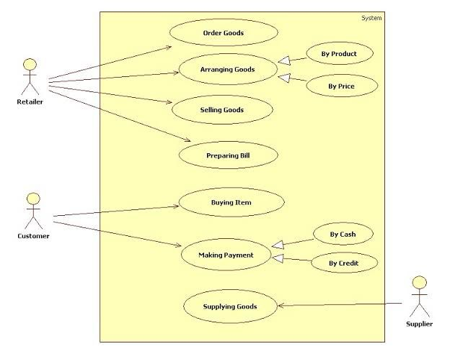



**5. Working Process:**

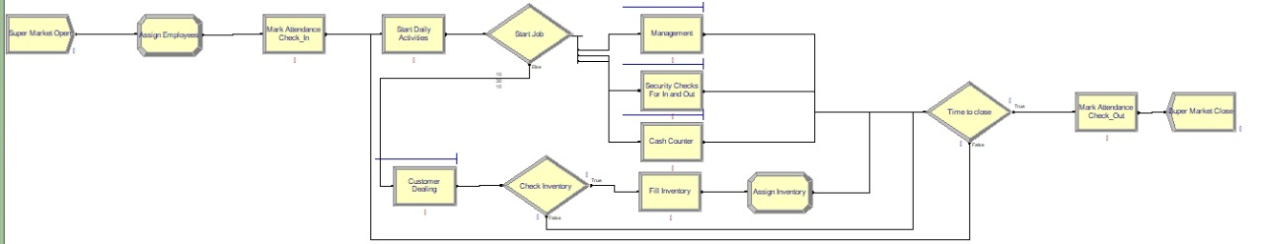

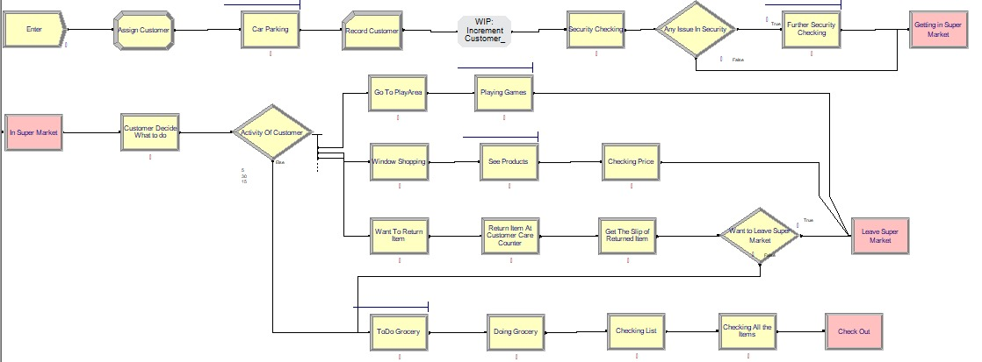

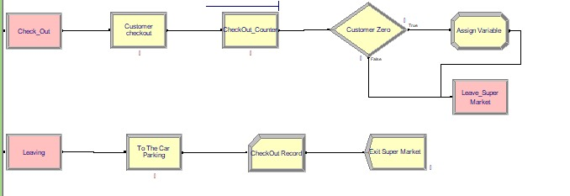

**6. Conclusion:**

In conclusion, the Supermarket Arena Model serves as a strategic asset for supermarket management, offering a simulated playground for experimentation, optimization, and continuous improvement. As technology continues to advance, this model stands poised to adapt and evolve, providing an ever-relevant tool for shaping the future of supermarket operations and customer experiences.

Top of Form